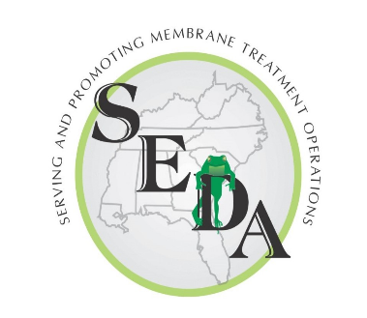
SEDA 2024 Symposium
Sponsor & Exhibitor Information
June 2nd -5th , 2024
Tampa, Florida

SEDA’s registration for Sponsors/Exhibitors is now open for the 2024 Symposium.
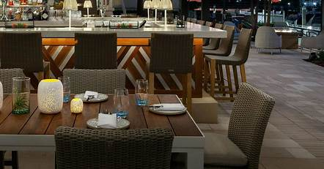
SEDA appreciates the support and involvement of our Division II members; our 2023 symposium was attended by over 100 Plant Operators, Managers and Experts in the membrane industry. Show your support for SEDA and gain exposure for your organization by sponsoring or exhibiting at this event.

SPONSORSHIP OPPORTUNITIES... Sponsorships are offered on a first‐ come first‐serve basis to SEDA Members and Non‐members. All sponsorships are
recorded based upon receipt of registration form and full payment.

EXHIBIT OPPORTUNITIES… Let Symposium attendees know what goods and services your company has to offer by hosting an exhibit space! This is a great way to meet the people who can use your products and/or services. Exhibitors must register and submit payment in full to select exhibit location at the event. All Sponsors will receive:
- List of attendees sent via e‐mail two weeks after the Symposium
- Acknowledgement in the attendee welcome packets
- General recognition during the program

Platinum Sponsor ‐ $2,500
- Includes 1 Exhibitor Package or 2 Full Registrations
- Sign Recognition at Meeting Room Entrance
- Recognition at 5 Session Starts, 5 Breaks and 2 Meals
- Logo in program

Gold Sponsor ‐ $2,000
- Includes 1 Exhibitor Package or 2 Full Registrations
- Recognition at 5 Breaks and 2 Meals.

Silver Sponsor ‐ $1,500
- Includes 1 Exhibitor Package or 2 Full Registrations
- Recognition at 5 Breaks.

Bronze Sponsor ‐ $1,000
- Includes 1 Exhibitor Package or 2 Full Registrations Recognition at 2 Meals.

Welcome Reception Sponsor ‐ $1,250
- Includes 2 Full Registrations
- Sign Recognition

Lunch Sponsor ‐ $1,000
- Includes 2 Full Registrations
- Recognition at Lunch

Lanyard Sponsor ‐ $500
- Recognition at Lunch

TABLETOP EXHIBITS: Only 20 Available - $850

ALL EXHIBIT SPACES WILL BE SELECTED ON A FIRST COME/FIRST SERVED BASIS AT THE TIME OF REGISTRATION AND PAYMENT IN FULL

All Exhibitors will Receive:
- One 6’ rectangular table (chairs available upon request)
- One full attendee registration to the Symposium
- Attendees list via e‐mail two weeks after Symposium
- Acknowledgement in the attendee materials
- General recognition during the program

SEDA 2024 Symposium
Sponsor & Exhibitor Information
June 2nd-5th , 2024
Tampa, Florida

Sponsor/Exhibitor Form

Name:___________________________________Title:_________________________________________
Company: _____________________________________________________________________________
MailingAddress:________________________________________________________________________
City:______________________________ State:________________ Zip:___________________________
Ph:__________________________Cell:_______________________E-mail:_________________________
Exhibitor Package: (must be a div. 1A or 2 members to exhibit)

$850 Tabletop
Sponsors please choose 1 of the following:

- Exhibitor Package

- 2 Full Attendees

Sponsor:
Platinum: $2,500

Gold: $2,000

Silver: $1,500

Bronze $1,000

Welcome Reception: $1,250

Lunch $1,000

Lanyard $500

Total Sponsorship Fee $

Checks may be made payable to Southeast Desalting Association or:

Credit Card #: __________________________________________ Exp. Date: ______________

Billing Address: _________________________________________________ CVV: __________
(If different from above)

Signature: _____________________________ Print Name: _____________________________

Southeast Desalting Association (SEDA)
P: 772-781-7698  E: registration@southeastdesalting.com
354 NW Alice Ave  Stuart, FL 34994  www.southeastdesalting.com

